Practice sheet on **Graphs**

**Practice Problems:**

1. Prove the handshaking lemma.
2. Find the graph and adjacency list from the given adjacency matrix:

|  |  |  |  |  |  |  |  |
| --- | --- | --- | --- | --- | --- | --- | --- |
|  | a | b | c | d | e | f | g |
| a |  | 1 | 1 |  |  |  |  |
| b |  |  | 1 | 1 |  |  |  |
| c |  |  |  | 1 |  |  |  |
| d |  | 1 |  |  | 1 | 1 | 1 |
| e |  | 1 |  |  |  |  |  |
| f |  |  | 1 | 1 |  |  | 1 |
| g |  |  |  |  | 1 |  |  |

1. Find the graph and adjacency matrix from the given adjacency list:

|  |  |
| --- | --- |
| Vertex | Adjacent vertices |
| a | a, b, d, e |
| b | a, b, c |
| c | a |
| d | c, e |
| e | b,c, e |
| f | c |

**4.** Determine if Euler’s path or circuit or both exists:

i)

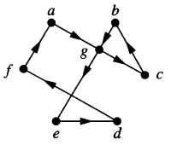

ii)

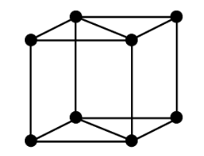

iii)

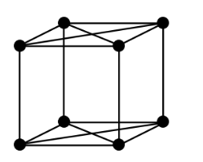

iv)

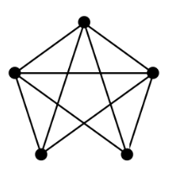

v)

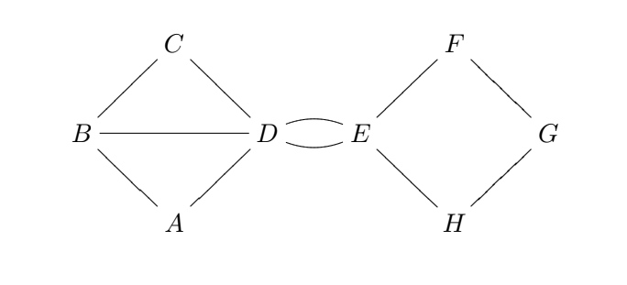

**5.** Find the adjacency matrix and list from the given graphs

i)

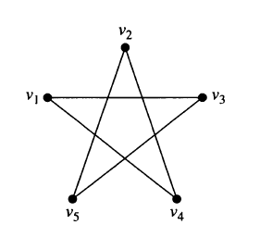

ii)

